E-Learning App

Submitted in partial fulfillment of the requirements of the degree of

(Masters in Computer Application)

by

Shaikh Arbaaz, 52

Mohit Devadiga, 09

Arfat Patel, 40

Group: B3 (MCA1B)

Supervisor:

Mrs. Indira Bhattacharya



(Department of Computer Applications)

VESIT

2021

**CERTIFICATE**

This is to certify that the project entitled **E-Learning App** is a bonafide work of **Shaikh Arbaaz** (52)submitted to the University of Mumbai in partial fulfillment of the requirement for the award of the degree of **Postgraduate** in MCA.

(Name and sign) (Name and sign)

Supervisor/Guide Co-Supervisor/Guide

(Name and sign) (Name and sign)

Head of Department Principal

**CERTIFICATE**

This is to certify that the project entitled **E-Learning App** is a bonafide work of **Mohit Devadiga** (09)submitted to the University of Mumbai in partial fulfillment of the requirement for the award of the degree of **Postgraduate** in MCA.

(Name and sign) (Name and sign)

Supervisor/Guide Co-Supervisor/Guide

(Name and sign) (Name and sign)

Head of Department Principal

**CERTIFICATE**

This is to certify that the project entitled **E-Learning App** is a bonafide work of **Arfat Patel** (40)submitted to the University of Mumbai in partial fulfillment of the requirement for the award of the degree of **Postgraduate** in MCA.

(Name and sign) (Name and sign)

Supervisor/Guide Co-Supervisor/Guide

(Name and sign) (Name and sign)

Head of Department Principal

Thesis Approval for Ph. D. / Dissertation Approval for M. E. / Project Report Approval for B. E.

This thesis / dissertation/project report entitled Peak Merit - by group

(B-3 MCA1B) is approved for the degree of MCA.

Examiners 1.

2.

Date:

Place:

**Declaration**

I declare that this written submission represents my ideas in my own words and where others' ideas or words have been included, I have adequately cited and referenced the original sources. I also declare that I have adhered to all principles of academic honesty and integrity and have not misrepresented or fabricated or falsified any idea/data/fact/source in my submission. I understand that any violation of the above will be cause for disciplinary action by the Institute and can also evoke penal action from the sources which have thus not been properly cited or from whom proper permission has not been taken when needed.

(Signature)

(Name of student and Roll No.)

Date:

ABSTRACT

Peak Merit is a web application that runs on android devices. The main purpose of this application is to provide the best in class mentorship and training to students. Students can sign up on the application, Enroll in different courses. The UI is also user friendly and no long procedures to enroll, its simple and fast. User can also browse for courses. Adding to this users get some tags related to the course they’ve enrolled, That makes browsing for courses easier. Users have to create an account which is mandatory for security purposes.

ACKNOWLEDGEMENT

Every Work that one completes successfully stands on the constant encouragement, good will and support of the people around. We, hereby, avail this opportunity to express our heartfelt gratitude to a number of people who extended their valuable time, full support and cooperation in developing this project. We convey our heartfelt gratitude to our University “**University of Mumbai**” for giving us this precious opportunity to work for the real-time project.

We wish to express our deep sense of gratitude to our college ‘**Vivekanand Education Society’s Institute of Technology**’ for giving us the opportunity to work on this Real time Project.

We convey our heartfelt gratitude to the ‘**Mr. Shivkumar Goel, Head of Department’** for giving us this precious opportunity to work for the real-time project.

We wish to express our deep sense of gratitude to our Internal Guide, **Mrs. Indira Bhattacharya** for her guidance and useful suggestions, which helped us in completing the project work in time. We owe the success of the project to her as she was a tremendous supporter and an eager teacher, for providing excellent guidance for this project. She is one of the major sources behind the success of the project. Finally, yet importantly, we would like to express our heartfelt thanks to our friends/classmates for their help and wishes for the successful completion of this project.

With regards,

Mr. Arbaaz Shaikh

Mr. Mohit Devadiga

Mr. Arfat Patel

**INDUSTRY DEFINED PROBLEM STATEMENT**

**PROBLEM SUMMARY:**

The drawback of the existing systems is that there was no proper course focusing on personal development. And also, The course length was large, which pushed the users quit the course before completing even half of the modules.

**EXPECTED OUTCOME:**

User will register in this system and can after that enroll in any course of his/her choice. And can also review Course.. This system provides user friendly interface resulting in ease of use and access every day. This system will enhance the user experience for the all the customers.

Contents

CHAPTER 1- INTRODUCTION 11

1.1 Background 11

1.2 Objective 12

1.3 Problem Definition 13

1.4 Scope 14

CHAPTER 2- PROJECT PLANNING 15

2.1 Feasibility Study 15

2.2 Project Timeline Chart 16

Chapter 3: Project design and analysis 17

3.1 Methodology 17

3.2 SRS documentation 18

3.3 Use case diagram 21

3.4 Activity diagram 22

3.5 Sequence diagram 23

3.6 Class diagram 24

Chapter 4: Project Implementation 25

4.1 Approach 25

4.2 Programming Languages Used 25

4.3 Tech Stack and Tools Used. 25

Chapter 5: Testing 26

5.1 Outputs 26

5.1.1 WEB Based 26

5.1.2 Android 32

5.2 Test Cases 33

Chapter 6: Coding Standard Followed 35

Chapter 7: References and Future Enhancements 36

Chapter 8: Conclusion 37

8.1 Conclusion 37

8.2 Future Scope 37

# CHAPTER 1- INTRODUCTION

## Background

The term “e-learning” has only been in existence since 1999 when the word was first utilized at a CBT systems seminar. Other words also began to spring up in search of an accurate description such as “online learning” and “virtual learning”. However, the principles behind e-learning have been well documented throughout history, and there is even evidence which suggests that early forms of e-learning existed as far back as the 19th century.

With the introduction of the computer and internet in the late 20th century, e-learning tools and delivery methods expanded. The first MAC in the 1980′s enabled individuals to have computers in their homes, making it easier for them to learn about subjects and develop certain skill sets. Then, in the following decade, virtual learning environments began to truly thrive, with people gaining access to a wealth of online information and e-learning opportunities.

## Objective

The objective of this document is to present a detailed description of the E-Learning System named Peak Merit. It will explain the purpose and features of the system, the interfaces of the system, what the system will do, the constraints under which it must operate and how the system will react to external stimuli. This document is intended for both the stakeholders and the developers of the system.

## Problem Definition

We have E-Learning apps that have students helping since classes as small as 5th-12th and for separate subjects for the UG and PG courses, but what we realized is that there are not many resources on the Internet that guides us towards preparing ourselves for the real challenge of the outside world, and maybe one of the most important test or exams that is the recruitment process which includes the interview, aptitude, etc. Therefore, there was a need for an app that provides graduates with such resources in one app without having to either waste time or worry about searching for such resources.

## Scope

This software system will be a E-Learning System for Students of different streams. This system will be designed to make the best possible use of lockdown. As we all know, Human never stops learning, so here we are with a beautiful idea that helps students utilize their free time learning. But knowledge is of no use if not utilized. That is the exception this software creates. The most important part of this software is the tests or call it exams.

More specifically, this system is designed to allow users to manage and keep track of what they learn, how they perform as well as customize what they want to learn. The software will facilitate communication between Students and the coordinator in the interface built with itself. Preformatted reply forms are used in different stages of the system to provide a uniform review process. The system also contains a document-based database containing a list of Students, Courses, Tests and Articles.

# CHAPTER 2- PROJECT PLANNING

## 2.1 Feasibility Study

* Accessing technology is one of the factors which can affect the feasibility of implementing an e-learning system. The access to e-learning technology in the use of computers, software and hardware is needed in the system. Students access to the appropriate Internet is necessary.
* The skills required for the use of computer, the ability to search for content on the internet, the ability to communicate with others through the Internet, ability to manage time while surfing the web, chat with others is the ability to problem-solving is necessary.
* Students seems more motivated towards the e-learning assessment, the learning materials used in the e-learning method have proved to be useful and bring a positive impact in their understanding.

## 2.2 Project Timeline Chart

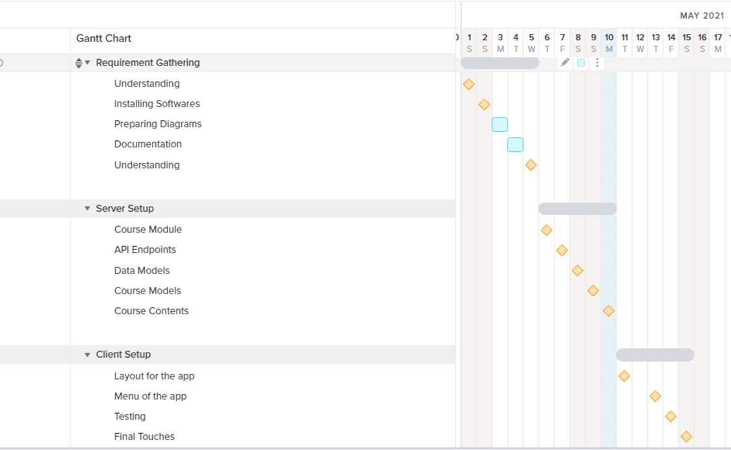

# Chapter 3: Project design and analysis

## 

## 3.1 Methodology

The Methodology used throughout this project is Feature Driven Development

* Develop overall model
* Build feature list
* Plan by feature
* Design by feature
* Build by feature

## 3.2 SRS documentation

Purpose: The purpose of this document is to present a detailed description of the E-Learning System. It will explain the purpose and features of the system, the interfaces of the system, what the system will do, the constraints under which it must operate and how the system will react to external stimuli. This document is intended for both the stakeholders and the developers of the system.

Scope of Project: This software system will be a E-Learning System for Students of different streams. This system will be designed to make the best possible use of lockdown. As we all know, Human never stops learning, so here we are with a beautiful idea that helps students utilize their free time learning. But knowledge is of no use if not utilized. That is the exception this software creates. The most important part of this software is the tests or call it exams.

More specifically, this system is designed to allow users to manage and keep track of what they learn, how they perform as well as customize what they want to learn. The software will facilitate communication between Students and the coordinator in the interface built with itself. Preformatted reply forms are used in different stages of the system to provide a uniform review process. The system also contains a document-based database containing a list of Students, Courses, Tests and Articles.

System Environment: The E-Learning System has Two active actors and one cooperating system.

The Admin or Coordinator accesses the entire system directly through the Internet. Any Student communicates with the system through separate Interface provided.

Functional Requirements Specification

This section outlines the use cases for each of the actors separately.

Student Use Case:

Before this use case can be initiated, the Student has already accessed the E-Learning Application.

1. The Student chooses to browse/search courses by subject name or tag.

2. The system displays the choices to the student.

3. The student selects the course desired and enrolls.

4. The system presents the abstract of the course to student.

5. The student chooses to access study material.

6. The system provides the requested documents.

7. The student post some query/doubt.

8. The system checks for list of FAQs.

9. The system responds with suitable answer for the query.

Before this use case can be initiated, the Student has already Enrolled for a course.

1. The Reader chooses to apply for the exam/ regular test.

2. The system displays the active exams going on.

3. The student appears for the exam(online).

4. The system presents the questions of the exam.

5. On successful Submission, The System provides a summarized result for the exam.

Admin Use Case:

1. Create Different Courses/Streams.

2. Manage Tests/Questions.

3. Manage Material.

4. Manage User Queries.

User Characteristics

The Student is expected to be Smartphone User and be able to use applications. The main screen of the E-Learning Application will have the search function and user dashboard.

Non-Functional Requirements

The Backend will be on a server with high-speed Internet capability. The software developed here assumes the use of a cloud services for connection between the Web pages/Client and the database. The speed of the Student’s connection will depend on the hardware used rather than characteristics of this system.

Functional Requirements

• Add Courses

• Add Material

• Add Tests

• Manage FAQs

• Respond to Queries

• User Registration

• Enroll

• Attempt Test

• Post Queries

• Attend Sessions

• Access Material

## 3.3 Use case diagram

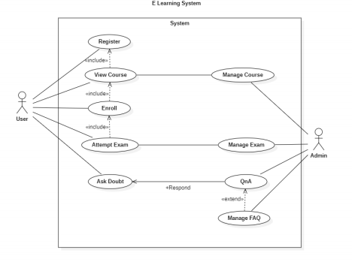

## 3.4 Activity diagram

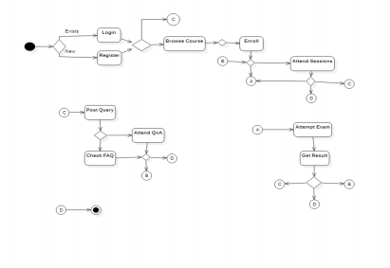

## 3.5 Sequence diagram

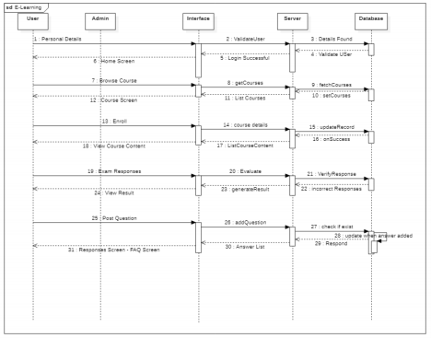

## 3.6 Class diagram

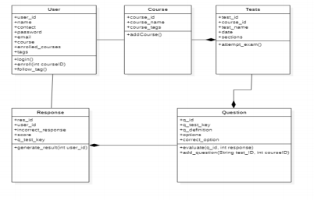

# Chapter 4: Project Implementation

## 4.1 Approach

FDD Approach

* Develop overall model
* Build feature list
* Plan by feature
* Design by feature
* Build by feature

## 4.2 Programming Languages Used

The programming languages used are:

* JavaScript
* Java

## 4.3 Tech Stack and Tools Used.

The tools and technologies used in this project are:

* Node
* Android
* Android Studio
* MongoDB Compass
* Framework Express, Mongoose, Retrofit
* VS Code
* Database MongoDB

# Chapter 5: Testing

## 5.1 Outputs

### 5.1.1 WEB Based

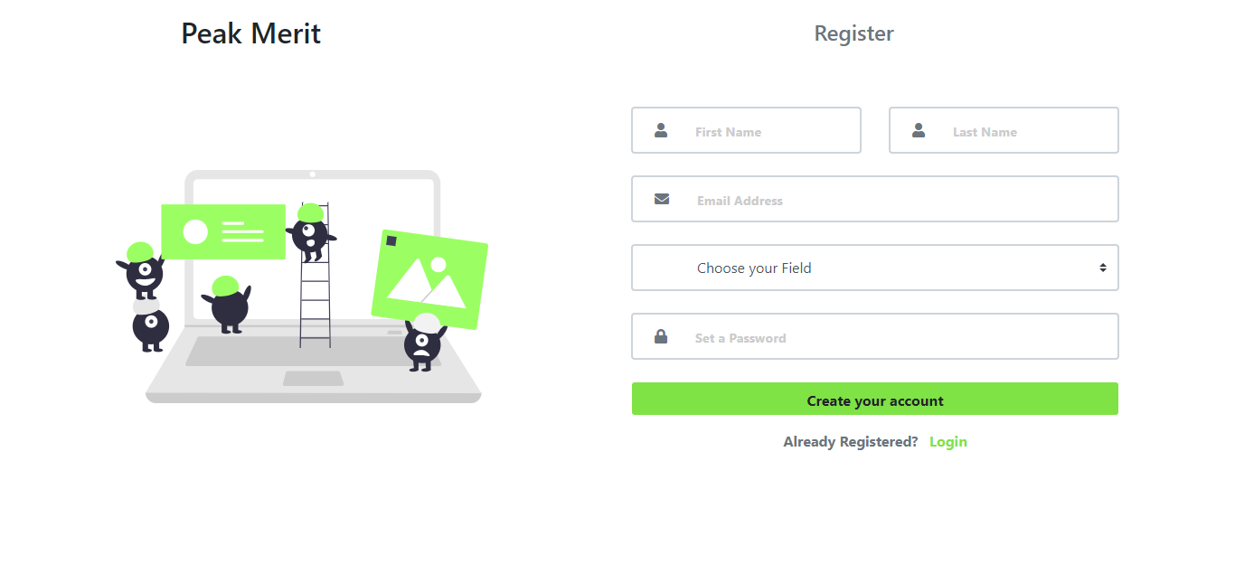

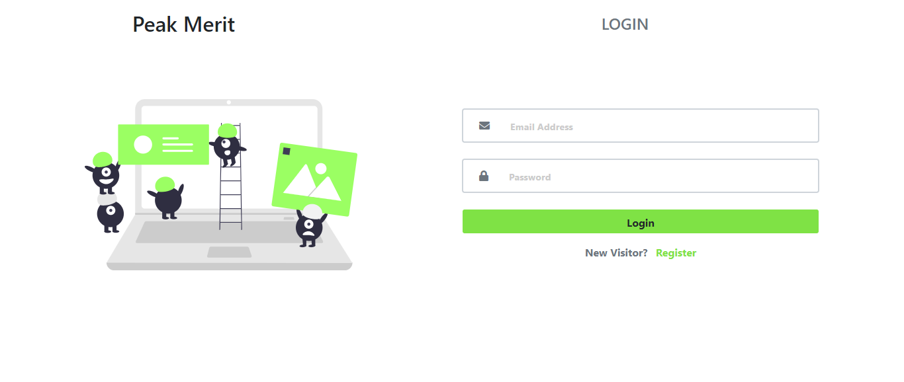

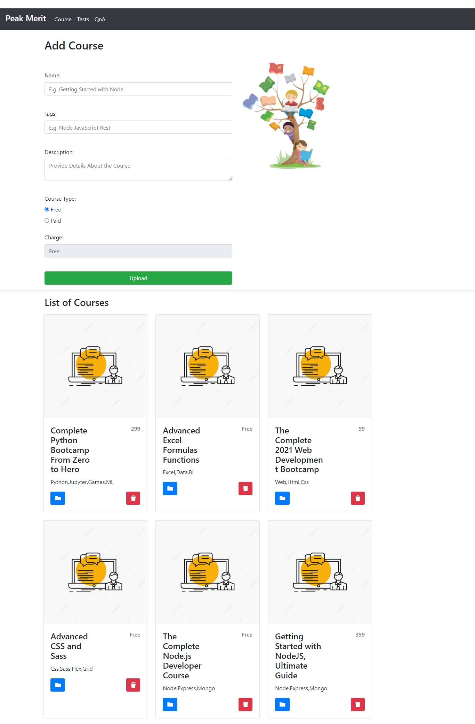

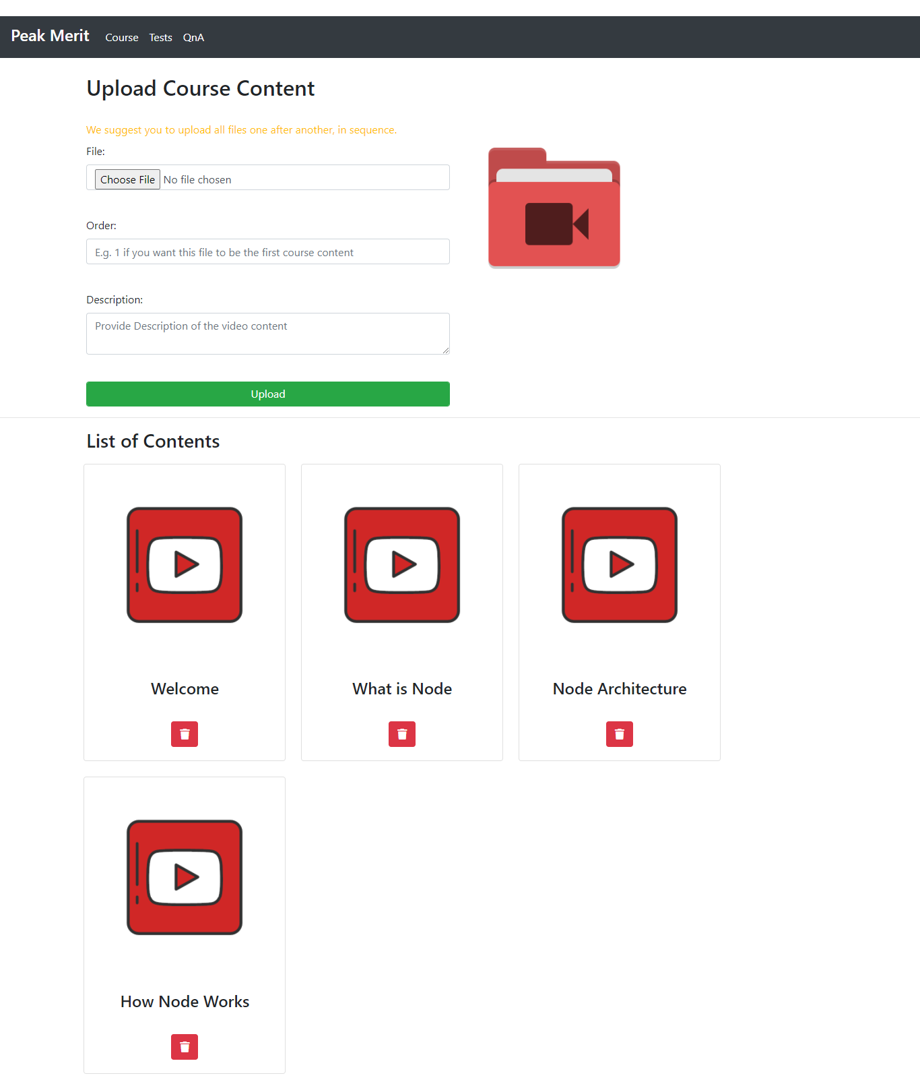

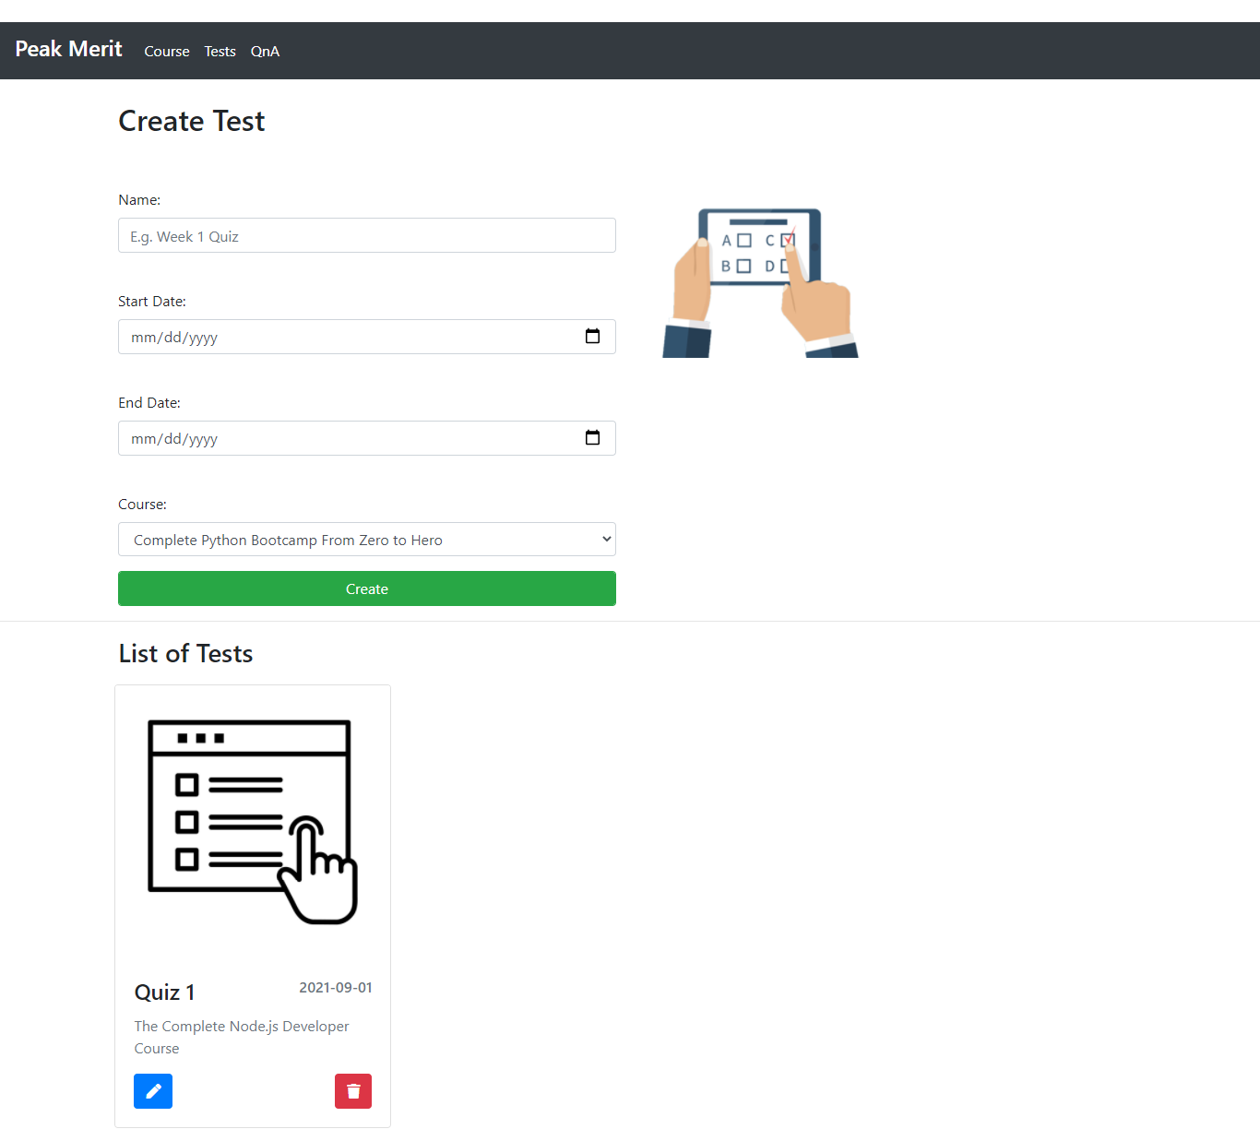

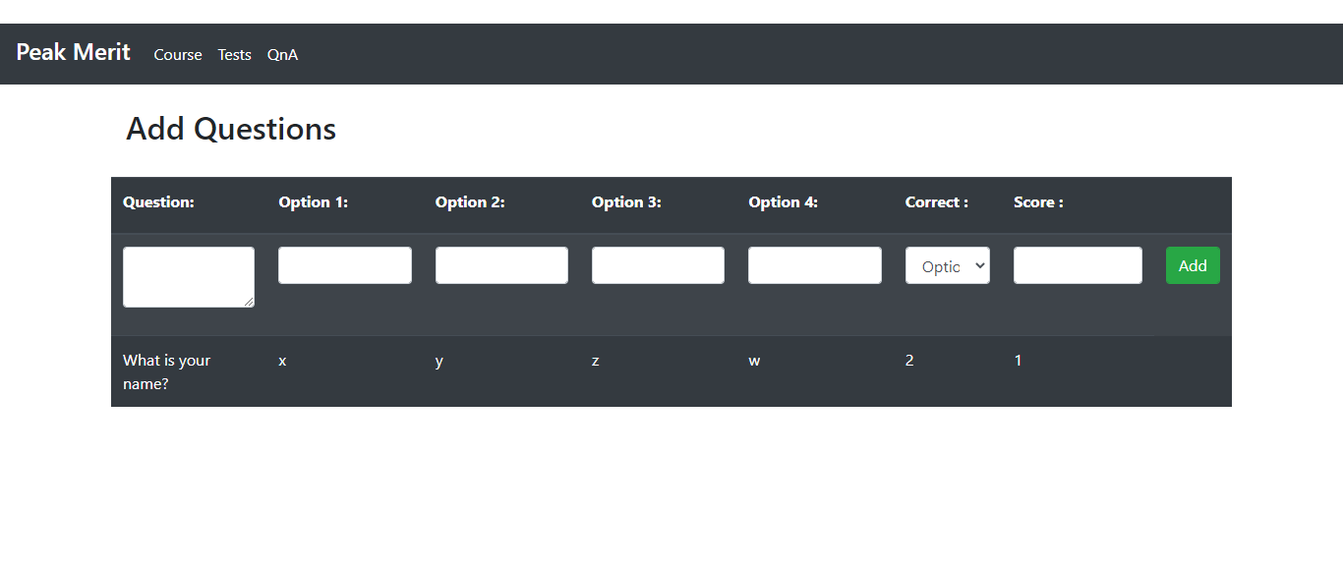

### 5.1.2 Android

|  |  |
| --- | --- |
|  |  |

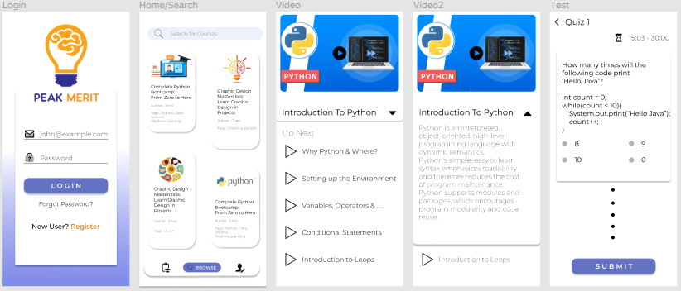

|  |  |
| --- | --- |
|  |  |

|  |  |
| --- | --- |
|  |  |

### 5.2 Test Cases

TC01 – User Signup – Successfully Logged in.

Prerequisites: Must have Peak Merit App installed in android device & Must not have

registered before with the email address to provide.

Test Priority: High

Steps:

|  |  |  |  |  |  |  |
| --- | --- | --- | --- | --- | --- | --- |
| S.no. | Action | Inputs | Expected Outcome | Actual Outcome | Test Device | Result |
| 1 | Launch  App | Click Icon | App opens->Navigate to Sign-up | App opens, with sign up button | Android smartphone | Pass |
| 2 | Enter Details and hit button | Name, Email, Password | Page should navigate to new activity. | Page navigates to home screen | Android Smartphone | Pass |

TC02 – User Login–Successful Login into the App.

Prerequisites: Must have Peak Merit App installed in android device & must have signed up

with a valid email address.

Test Priority: High

Steps:

|  |  |  |  |  |  |  |
| --- | --- | --- | --- | --- | --- | --- |
| S.no. | Action | Inputs | Expected Outcome | Actual Outcome | Test Device | Result |
| 1 | Launch  App | Click Icon | App opens | App opens | Android smartphone | Pass |
| 2 | Enter Details and hit button | Email, Password | Page should navigate to new activity. | Page navigates to home screen | Android Smartphone | Pass |

TC03 –Search Products.

Prerequisites: Must have Peak Merit App installed in android device & must be logged in the

App

Test Priority: Medium

Steps:

|  |  |  |  |  |  |  |
| --- | --- | --- | --- | --- | --- | --- |
| S.no. | Action | Inputs | Expected Outcome | Actual Outcome | Test Device | Result |
| 1 | Launch  App | Click Icon | App opens | App opens | Android smartphone | Pass |
| 2 | Get List of Courses |  | Page should display all available courses on the server | Page displays all available courses on server | Android Smartphone | Pass |

TC04 –Enroll.

Prerequisites: Must have Peak Merit App installed in android device & must be logged in the

App

Test Priority: Medium

Steps:

|  |  |  |  |  |  |  |
| --- | --- | --- | --- | --- | --- | --- |
| S.no. | Action | Inputs | Expected Outcome | Actual Outcome | Test Device | Result |
| 1 | Launch  App | Click Icon | App opens | App opens | Android smartphone | Pass |
| 2 | Open a course | Click a course of your choice | Page should display course details and enroll button | Page displays relevant information | Android Smartphone | Pass |
| 3 | Enroll | Hit Enroll Button | User Should be updated and enrolled course must show in users profile | Course is seen in user’s learning tab | Android Smartphone | Pass |

# Chapter 6: Coding Standard Followed

OOP:

* Encapsulation- The implementation and state of each object are privately held inside

a defined boundary, or class. Other objects do not have access to this class or the

authority to make changes but are only able to call a list of public functions, or

methods. This characteristic of data hiding provides greater program security and

avoids unintended data corruption.

* Abstraction- Objects only reveal internal mechanisms that are relevant for the use of

other objects, hiding any unnecessary implementation code. This concept helps

developers make changes and additions over time more easily.

* Inheritance- Relationships and subclasses between objects can be assigned, allowing

developers to reuse a common logic while still maintaining a unique hierarchy. This

property of OOP forces a more thorough data analysis, reduces development time and

ensures a higher level of accuracy.

* Polymorphism- Objects are allowed to take on more than one form depending on the

context. The program will determine which meaning or usage is necessary for each

execution of that object, cutting down on the need to duplicate code.

Limited the Use of Global Variables.

Standard Headers for Different Modules.

Simple and understandable naming conventions

Proper Indentation.

Error Handling and Proper Error Messages.

Short Length Functions Used.

# Chapter 7: References and Future Enhancements

References:

* https://developer.android.com/reference
* Unified Modeling Language, second edition by Booch, Rumbaugh and Jacobson
* <https://nodejs.org/en/docs/>

Future Enhancements:

* Use of Data analytics to provide content as per user’s capability
* User tags to suggest course related to student’s field of study
* Daily Tests to help student know the weakness and strengths
* Live Author Interaction with students for better understanding of concepts.

# Chapter 8: Conclusion

## 

## 8.1 Conclusion

This e-learning app is one of a kind because the motive of this app is not just to educate the students but to help them engage into this learning activity in such a way that it does not burden the student, rather it creates curiosity to gain knowledge using the app and therefore utilizing their free time into something much productive.

## 8.2 Future Scope

The future scope for this project has a vast amount of idea to cover not just syllabus or bookish theory but also help the student after graduation by preparing them for interview by providing tips and tricks and also helping them prepare themselves for the technical, HR and Aptitude rounds.